I have created AWS account with other Mail so name is different instead of my name.

Project 1:

1. Creating an windows instance

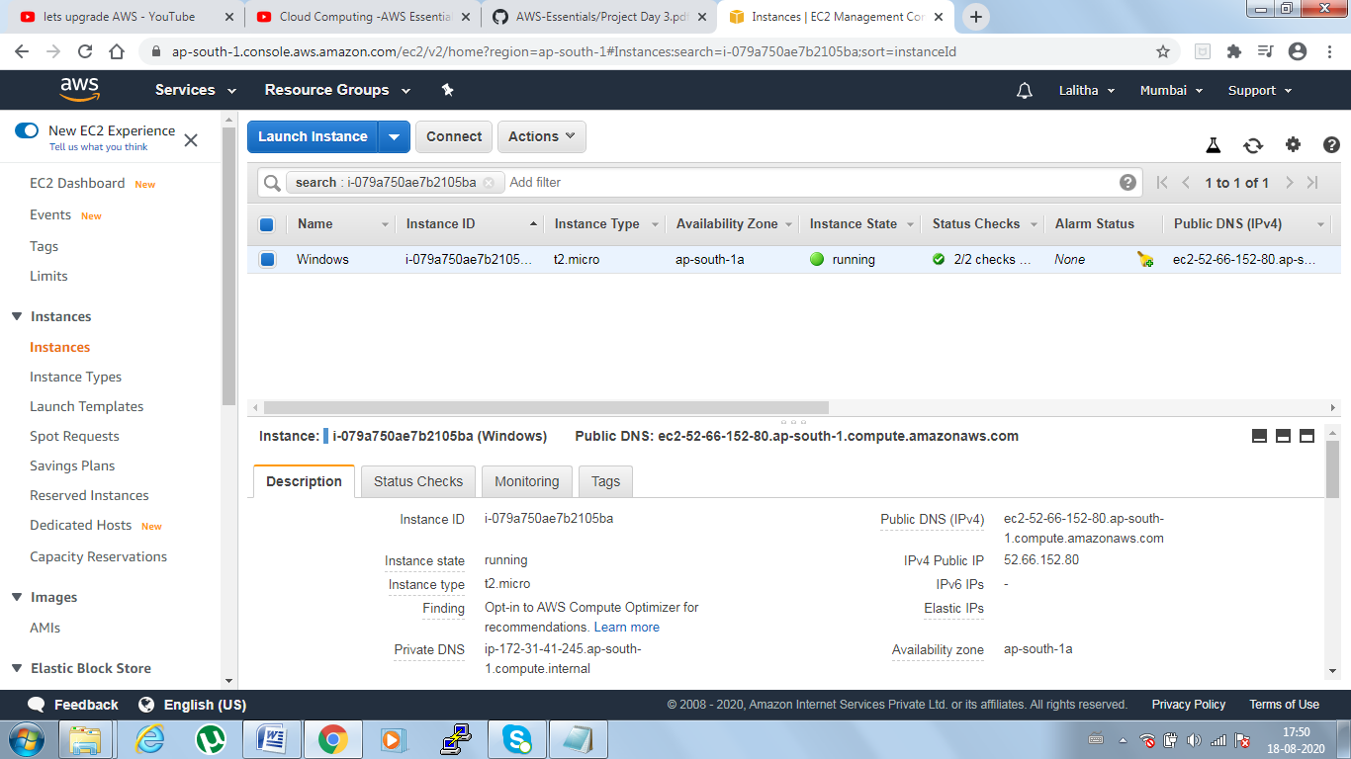

1. Launch instance using RDP

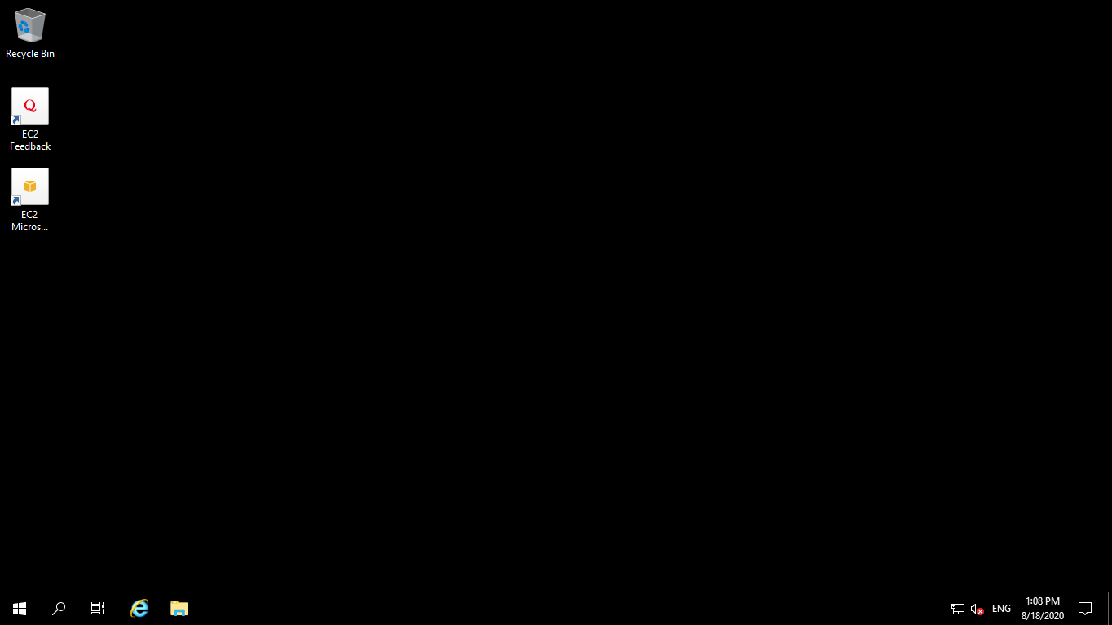

1. Installing webserver

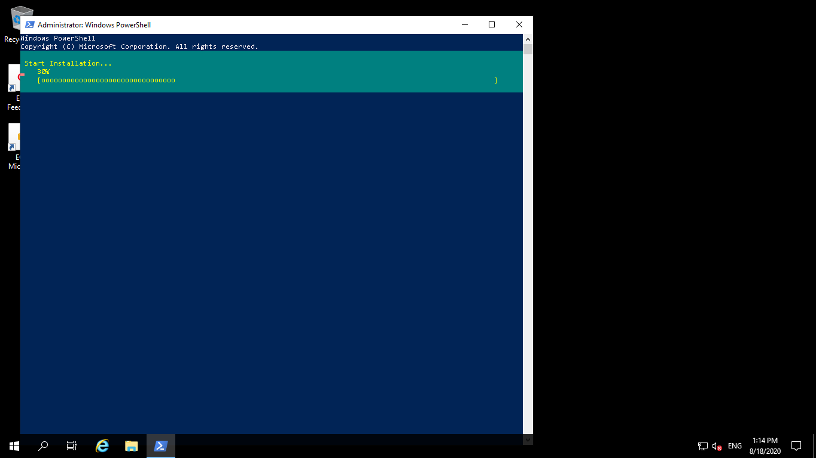

1. Verifying successful installation of webserver

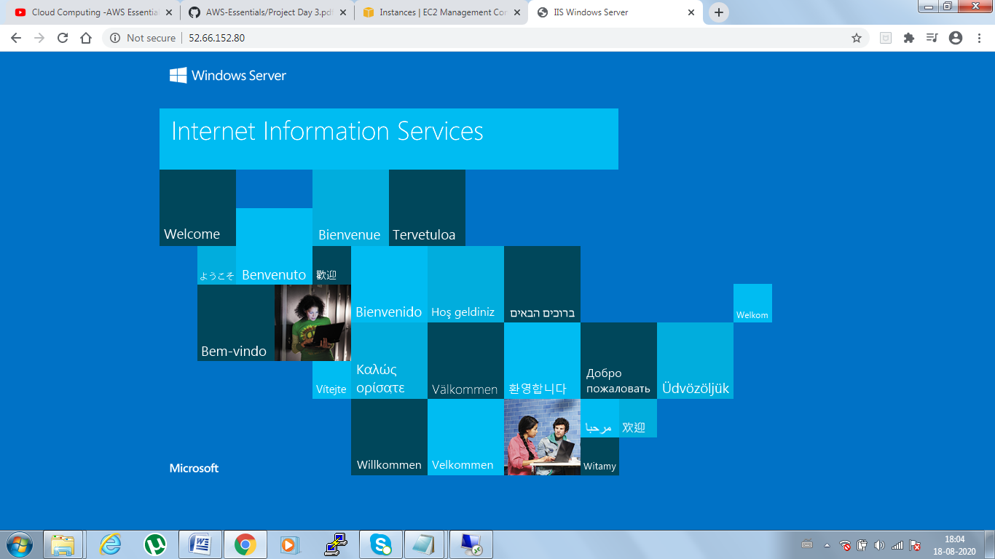

PROJECT 2:

1. Create and launch Ubuntu instance

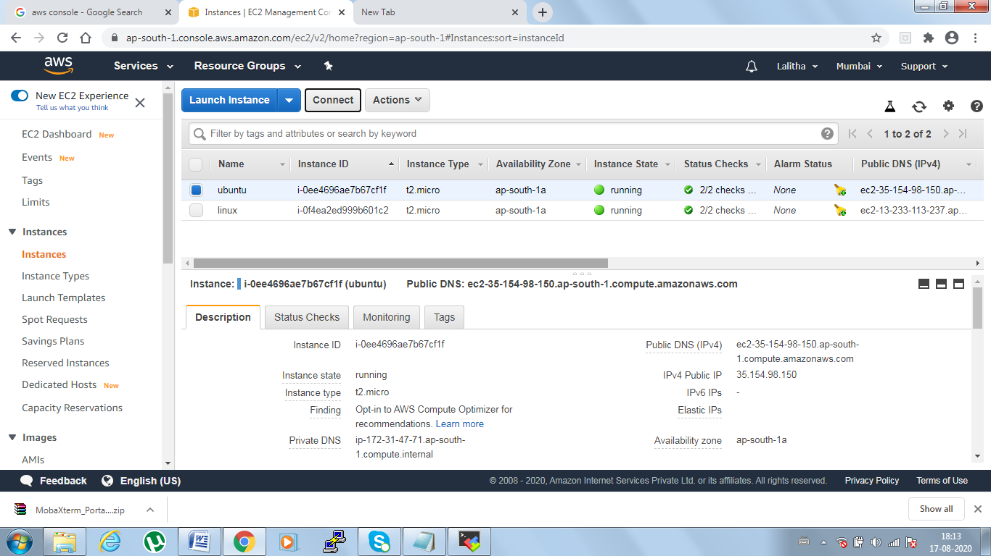

1. Install ngnix

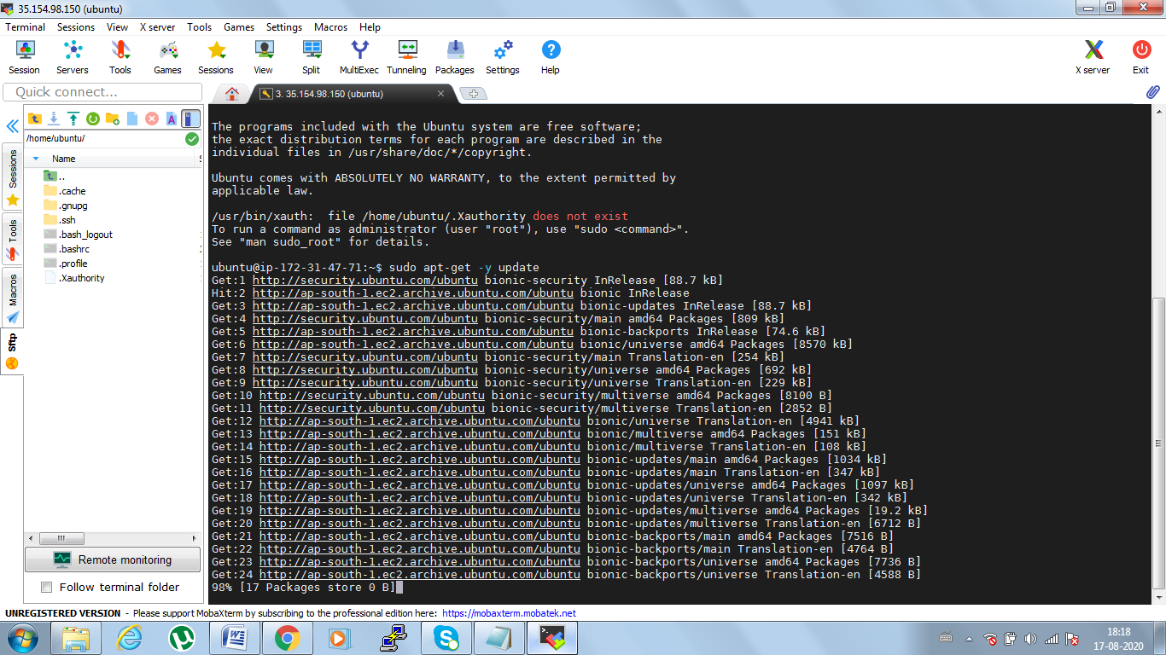

1. Verifying successful installation

